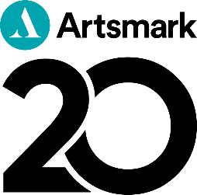

Your #Artsmark20 school library story guidelines

Imagine you are telling your Artsmark story to a friend, or a teacher from another school.

You might find it helpful to respond to our key questions below:

Who we are:
- Brief intro about your setting and your history with Artsmark – where you are on your Artsmark journey (e.g. long-standing, working towards, recently awarded)

Your school library: (Answer 2 or more from the below)
We’d like to hear more about:
- Why you think library provision at school is important
- What your school library is like, and/or how you’re hoping to develop your library provision
- What have been the challenges? What have you learned about the impact of children and young people?
- How does your school library relate to your Artsmark journey?

What’s next for you? (Answer one of the below)
- What’s your advice for other teachers/heads?
- Any new creative collaborations, networks or projects you’re involved in relating to your library?
- Will you continue to advocate for Artsmark?

Style Guidelines:
- Keep it brief and write no more than 500 words
- Break it up with headings or bullet points
- Send in photos or video links via our online form
- If you’re too short of time to send back the above, we’d still love to hear from you. You could write a short paragraph, provide a testimonial, or send us some photos of a key Artsmark project/outcome and describe it briefly for us.

Send your blog to Artsmark@artscouncil.org.uk

