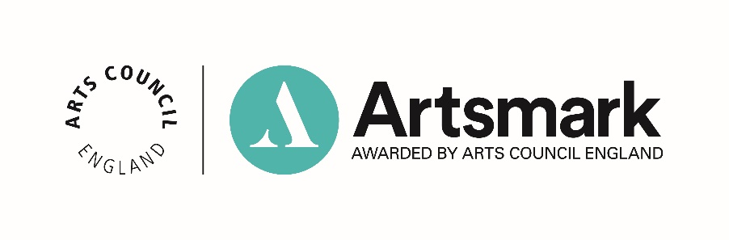
Template press release
For youth offending teams or sixth form colleges, please use this template and replace ‘school’ with ‘setting’ or ‘college’ as appropriate.

FOR IMMEDIATE RELEASE
Date

[Name of school] receives prestigious Artsmark Award
Pupils and staff at [name of school] are celebrating after receiving a prestigious Artsmark Award. Artsmark is Arts Council England’s award for schools and education settings that champion cultural education. It celebrates settings that embrace the arts across the curriculum, bringing them to life for children and young people.
In order to achieve their Artsmark Award, [name of school] had to develop their arts and culture provision to embed a broad and balanced curriculum. This was achieved by creating an overall plan that was committed to and delivered across the whole school.
[Name of school] was supported by [name of local Bridge organisation] in planning and developing their initial objectives. [Name of local Bridge organisation] worked alongside the school at various stages to support their Artsmark Award achievement.
[Quote from local Bridge organisation, if applicable.]
”As an Artsmark school, [name of school] gained access to exceptional networks and resources from some of the most treasured cultural organisations in the country, which helped to strengthen and deliver their arts provision. Through Artsmark, [name of school] will continue to incorporate art and culture into every pupil’s life, learning, knowledge and understanding, helping them to build skills, resilience, confidence and character.”
On receiving the award, [name of headteacher/chair of governors, job role] said: “We’re extremely proud of achieving our Artsmark [level] Award. We are committed to delivering a high-quality arts and cultural education and we look forward to continue to grow with Artsmark.”
Darren Henley, Chief Executive of Arts Council England, said:
“I would like to congratulate [name of school] on their Artsmark Award. As an Artsmark school, [name of school] exemplifies how the Award can help schools to achieve a broad and balanced curriculum, ensuring that each of its pupils is given the opportunity to explore and build a love of the arts that will remain with them as they go through adult life.”

Ends

For more information or images, contact [fill in name/number and email of contact at school]

Notes to editor:
[Insert information about your school]

About Artsmark Award
The Artsmark Award has been created to help unlock the potential of children and young people, to develop their character and talent, and increase their knowledge and understanding. In short, Artsmark has been designed to bring the arts and culture to life in every classroom.
Awarded by Arts Council England, Artsmark is designed by schools, for schools, to help them deliver high quality art and cultural education.
Across the country Artsmark is rewarding more and more schools and education settings for championing the arts and culture. Artsmark schools gain access to exceptional resources as well as networks of the country’s most treasured cultural organisations, helping them develop and strengthen their art provision.
Visit artsmark.org.uk for more information.

About Arts Council England
Arts Council England is the national development body for arts and culture across England, working to enrich people’s lives. We support a range of activities across the arts, museums and libraries – from theatre to visual art, reading to dance, music to literature, and crafts to collections. Great art and culture inspires us, brings us together and teaches us about ourselves and the world around us. In short, it makes life better. Between 2018 and 2022, we will invest £1.45 billion of public money from government and an estimated £860 million from the National Lottery to help create these experiences for as many people as possible across the country.

Visit artscouncil.org.uk for more information.

